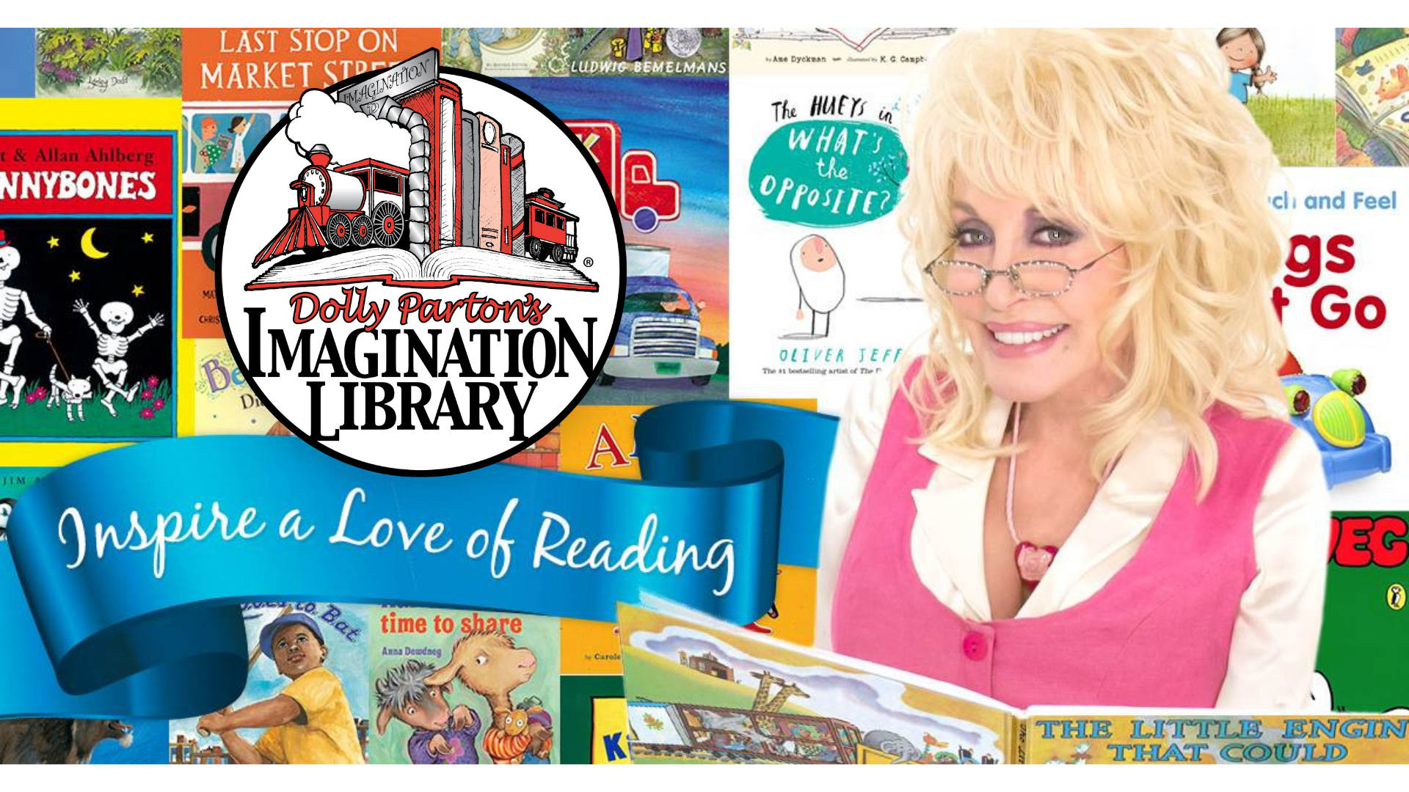
Enroll your child in Dolly Parton’s Imagination Library today!
imaginationlibrary.com[Your DPIL Website]

In a matter of minutes, you can begin your child’s Imagination Library journey! Children from birth up to age five can sign up to receive a new book each month at no cost to you. Just visit imaginationlibrary.com[Your DPIL Website], click enroll and answer a few simple questions, and your child will begin receiving a new book tailored to their age group in your mailbox each month.

